  - Linked Magazine

Business Directory Listing

PRICES
Price List
www.linkedmagazine.co.uk
editor@linkedmagazine.co.uk

Listing with us puts your business ahead of the competition. Potential customers will find your business when they search online.

Research shows that nearly all new business will come via an online search using Smartphones, tablets & computers.
- Search engines rank the businesses they know most about and trust in their top listings. Their aim is to deliver a good user experience, and to do that, they constantly 'crawl' for other sources of business information on the Web to verify your data.
- In addition to providing search engines with a way to validate local business data, our directory links back to the business’ website. This natural, trusted backlink provides a local and relevant link that enhances your local SEO results in the SERPs.
- Our interactive directory platform also has backlinks to all social media pages, an interactive map and trusted content information around your business, which further validates your business with Google (et al). This is not a static directory (most are).
- Google loves active hyperlocal directories with good written content. Our magazine content is laden with search terms for the area, is packed with quality hyperlinks to websites and will be favoured by search engines when potential new customers are searching online.

Your website will be ranked higher in the search engine rankings. “When we searched for our business using specific search terms, it didn’t show up on the first few pages of Google. Within a couple of months of listing with Linked Magazine we were near the top of page 1. It made a huge difference to us, and we already had a good website and actively use social media.”

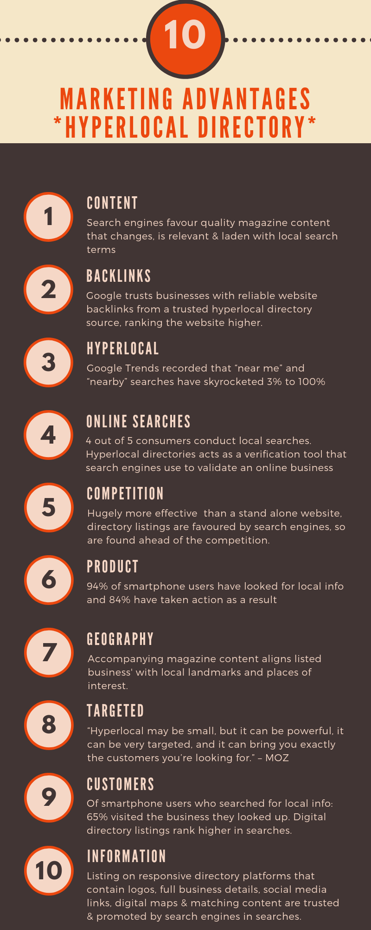
To list your business with us starts at only £120 for an entire year.

“Delighted with the look of my business listing. New orders already as a direct result. Excellent value and effective marketing.” Buchanan Homeware

“I cannot recommend Linked Business Directory advertising highly enough. The advertising space is worth its weight in gold. Very accommodating.” W Brown

“Linked Magazine is a really valuable resource and a breath of fresh air amidst some other local advertising.” Old Mill

“Linked Magazine delivers a great service. They take the initiative to promote your business. Worthwhile listing your business with them.” Art4You

“Delighted with our business directory listing. It looks fantastic, and has brought a lot of new customers our way. Friendly service and highly recommended.” Amore Hair & Beauty

BASIC DIRECTORY LISTING £120 for one year
(£10 per month)

- Your business listed within our responsive digital directory
- Professionally written business description & listing
- Click-through links to your website and social media pages
- Digital location map for you business
- Notes to include business awards, accolades & qualifications
- Use of up to 4 photographs on profile to showcase business
- Sharing x1 weekly of any social media post (tag @LinkedMagz)

ENCHANCED DIRECTORY LISTING £240 for one year
(£20 per month)

- Your business listed within our responsive digital directory
- Professionally written business description & listing
- Click-through links to your website and social media pages
- Digital location map for you business
- Notes to include business awards, accolades & qualifications
- Use of up to 4 photographs on profile to showcase business
- Sharing x2weekly of any social media post (tag @LinkedMagz)
- Upload of 1 video on profile to showcase your business
- Actively promote your upcoming events on social media
- A short magazine article introducing your business

PREMIUM DIRECTORY LISTING £480 for one year
(£40 per month)

All of the above, plus*
- Leaderboard or Skyscraper Ad for one month on home page or beside articles within digital magazine (worth £80- £100 per month)
- Design of leaderboard ad
- Enhanced SEO of search terms within directory listing
- Feature article (worth £120) on an event or specific aspect of your business – this can include images and video footage- which greatly enhances search engine rankings
- Active promotion of all social media posts (tag @Linkedmagz)

ADDITIONAL ADD-ONS AVAILABLE

- Feature Article £120 (£200 for businesses not listed)
Featuring an event or a specific aspect of your business – this can include images and video footage, incl links. Professionally written by a journalist. This is greatly beneficial to your business in terms of customer awareness and trust, as well as further assisting search engine rankings.
Event Focus £80 (£120 for businesses not listed) a short informational article that offers a description and specifics around upcoming exhibitions, shows, events etc, incl links.

- Banner Advertising £80-£100 per month
When spaces are available, we can offer leaderboard ads, skyscraper ads and rectangular ads within the digital magazine. We will also promote on social media that month.

- Professional Content Writing
Content & copywriting for websites, marketing material, brochures, e-books.

- Wordpress Website Design & Content £250

